**Symbol rate (Bod)** : maximum rate at which consecutive chunks of data can be sent without blending together on the receiving end (think music notes played too fast and becoming unable to recognize to the human ear): eg, with morse code, the minimum interval between two letters. You can increase the symbol rate by increasing the number of signaling events, this is indeed a nice workaround around the limit. You can of course send three dots to signal an “s”, but wouldn’t it be faster if you could represent “s” with two symbols instead of three? Because there are less combinations possible, you would need a larger variety of symbols. If there are too many, however, it will be affected by the background noise. We have to strike an equilibrium.

**Symbol:** Fixed state of a signal observable at a given moment in time

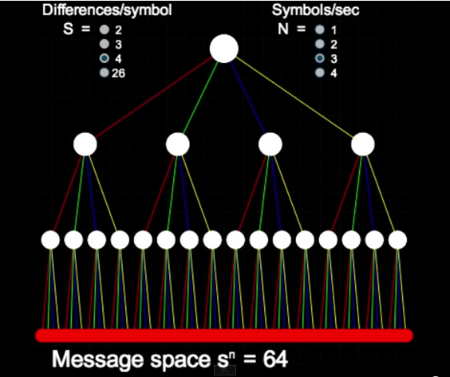

In this example, you can send 4^3=64 different symbols per second.

H: Information

n: number of symbols we want to transmit

s: number of symbols available to transmit info

H = n x log s (Hartley)